**Operating System**

**4th Semester, Academic Year 2025**

Date:29-01-2025

| Name: Rithvik Rajesh Matta | SRN: PES2UG23CS485 | Section H |
| --- | --- | --- |

Unit#____1_______ Program Number: ___5____

**Q5) Write a program to demonstrate the priority scheduling algorithm and calculate average TAT and WT**

**CODE:**

#include <stdio.h>

void sortProcessesByPriority(int processes[], int n, int bt[], int priority[]) {

for (int i = 0; i < n - 1; i++) {

for (int j = 0; j < n - i - 1; j++) {

if (priority[j] > priority[j + 1]) {

int temppriority = priority[j];

priority[j] = priority[j + 1];

priority[j + 1] = temppriority;

int temp = bt[j];

bt[j] = bt[j + 1];

bt[j + 1] = temp;

int tempProcess = processes[j];

processes[j] = processes[j + 1];

processes[j + 1] = tempProcess;

}

}

}

}

void findwtTime(int processes[], int n, int wt[], int bt[]) {

wt[0] = 0;

for (int i = 1; i < n; i++) {

wt[i] = bt[i - 1] + wt[i - 1];

}

}

void findtatTime(int processes[], int n, int wt[], int bt[], int tat[]) {

for (int i = 0; i < n; i++) {

tat[i] = bt[i] + wt[i];

}

}

void findavgTime(int processes[], int n, int bt[], int priority[]) {

int wt[n], tat[n], tot_wt = 0, tot_tat = 0;

sortProcessesByPriority(processes, n, bt, priority);

findwtTime(processes, n, wt, bt);

findtatTime(processes, n, wt, bt, tat);

printf("Processes BurstTime WaitingTime TurnaroundTime Priority\n");

for (int i = 0; i < n; i++) {

tot_wt += wt[i];

tot_tat += tat[i];

printf(" %d\t %d\t \t %d\t\t %d\t %d\n", processes[i], bt[i], wt[i], tat[i], priority[i]);

}

float avg_wt = (float)tot_wt / (float)n;

float avg_tat = (float)tot_tat / (float)n;

printf("Average Waiting Time = %.2f\n", avg_wt);

printf("Average Turnaround Time = %.2f\n", avg_tat);

}

int main() {

int processes[] = {1, 2, 3, 4 , 5};

int n = sizeof processes / sizeof processes[0];

int burst_time[] = {10, 5, 8, 6, 4};

int priority[] = {5, 2, 3, 8, 7};

findavgTime(processes, n, burst_time, priority);

return 0;

}

**Screenshot:**

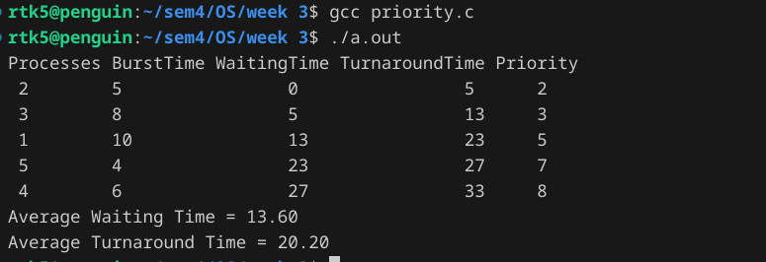

If found plagiarized, I will abide with the disciplinary action of the University.

Signature:

Name: Rithvik Rajesh Matta

SRN: PES2UG23CS485

Section: H

Date: 30/1/25